Simulations Module

Team TechKnights’ Alliance - AIITRA ‘21

# Scoring criteria :

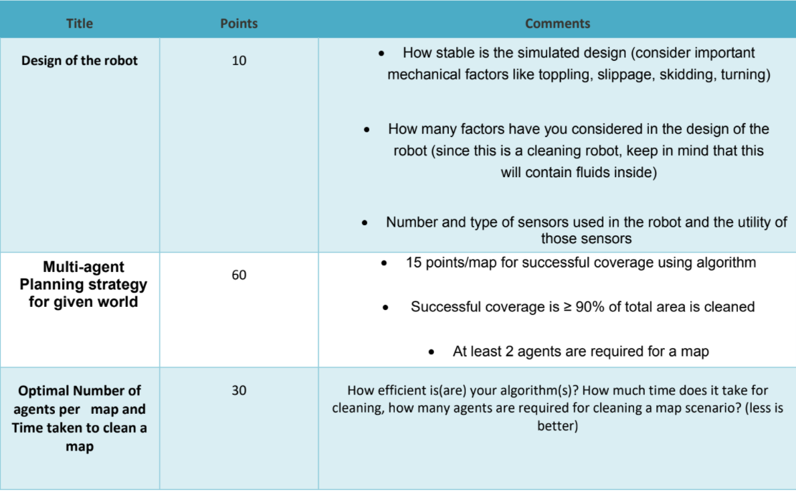

# Objectives (Module relevant) :

Go through implementation of : <https://github.com/alice-st/DARP>

Reference in Java : https://github.com/athakapo/DARP

Supporting Library : <https://github.com/cpswarm/swarm_functions/tree/kinetic-devel/area_division>